[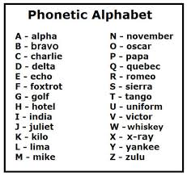](https://www.google.ca/url?sa=i&url=https://wallpapersafari.com/phonetic-alphabet-wallpaper/&psig=AOvVaw0nWAfBoGqsE6HH5tFMRYpw&ust=1612464678408000&source=images&cd=vfe&ved=0CAIQjRxqFwoTCLi2q52xzu4CFQAAAAAdAAAAABAD)